Bradshaw, Ben, Dr (from Linked in)
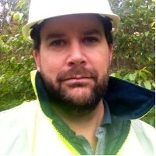

Nursery Supervisor Department of CALM 1993 – 96 Manjimup, W.A. Field Assistant Department of CALM, Forest Management Branch 1997 Manjimup, WA. Armillaria & dieback surveys in native forest. Maintenance and assessment of growth plots in production forest. Edith Cowan University Bachelor of Science (BSc) (Hons), Biological Sciences 1996 – 99. Research Assistant Edith Cowan University 2000 at Mt Lawley. Murdoch University PhD, Plant Physiology/Fungal Ecology 2001 –05. Project Supervisor Timbercorp Forestry 2005 –07 Penola, South Australia. Silviculture Manager Timbercorp Forestry 2007 –09 Penola, S.A. Research and Development Manager Australian Bluegum Plantations Pty Ltd October 2009 – at Albany. Registered Professional Forester: General Practicing Forester Institute of Foresters of Australia January 2010 – .

